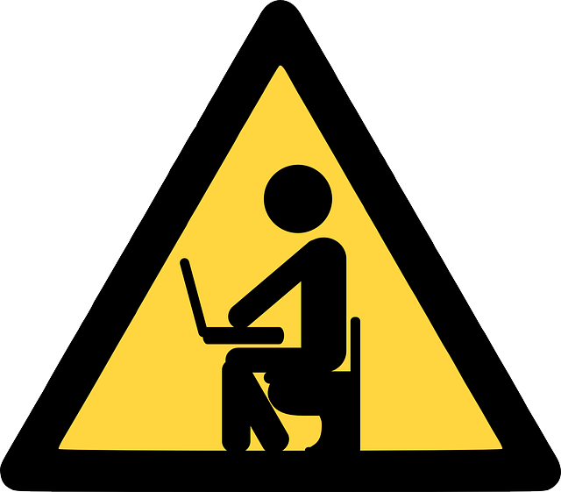
White Cloud Public Schools

- to - 1 Student Mobile Device Handbook

Overview

Student Mobile Device Agreement

Student Mobile Device Use

Student Mobile Device Care

Parent/Guardian Responsibilities

Liability: Loss, Theft, and Damage

Student Mobile Device Signature Form

1-to-1 Overview
White Cloud Public Schools (WCPS) views the use of student mobile devices as essential to personalization of learning and preparing students for the 21st Century. At Grades 3-12, Laptops will provide students with access to the Web, Google Docs, Google Groups, and other Web 2.0 tools. 1:1 access will make these tools readily available to students.

Personalization of Learning
Personalization of learning changes the role of the teacher from expert/lecturer to guide/facilitator.
Instead of defining all work parameters and choosing a tool to use, students participate in that process.
With personalization, students:
- actively participate in designing learning
- take ownership of rigorous and meaningful learning
- connect learning with interests
- develop skills and knowledge through the learning process
- become self-directed
- collaborate with other learners, teacher(s), family, …

In one model, the flipped classroom, instead of lecturing and demonstrating concepts, the teacher provides students with the content in another form, such as a video to watch before the class session. Then, when the students come to class, they work with the concepts collaboratively with other students, and the teacher circulates to guide, question, and support the student work. In another model for research, the teacher presents a broad guiding question in an online discussion. The students share ideas online before splitting into groups to work to define and narrow the question, find relevant and reputable information, and demonstrate understanding through a project - using the collaborative Google Docs platform.

Collaboration
Collaboration is a driving force in today’s workplaces, and students need to learn this skill. Google Drive/Docs allows students to share and collaborate on documents - amongst themselves, with their teachers, and with others in the community and around the world. Google Groups, online discussion groups, allow students to extend discussion and collaboration beyond the classroom and the regular school hours.

Student Mobile Device Agreement

Access to Student Mobile Devices
- The term “student mobile device” refers to devices, batteries, and power cord/chargers.
- Like textbooks, student mobile devices are considered as essential learning tools.
- Student mobile devices are on loan to students and remain the property of WCPS.
- All student devices are labeled with an WCPS tag and bar code. In addition, all power cords, and laptops will be labeled with the student's name. Students may be charged up to the full replacement cost of the student mobile device for tampering with, or turning in, a student mobile device without the WCPS tag and bar code.
- The students to whom the mobile devices are checked out are responsible at all times for appropriate use. This means that if others use the student devices to break the rules, the students may still be held responsible.
- Students are expected to keep the student mobile devices in good condition. Failure to do so may result in bills for repair or replacement.
- Students are expected to report any damage to their student mobile devices as soon as possible. This means no later than the next school day.

Content and Privacy
- All users are accountable to all school, district, local, state, and federal laws.
- All data stored on student mobile devices, the WCPS network, and Google Apps cloud servers are property of the district and may be subject to review and monitoring at any time.
- Additional user accounts created on the student mobile device are subject to the same terms and conditions as the assigned student user.
- Students are expected to notify a staff member immediately if they come across information, images, or messages that are inappropriate, dangerous, threatening, or make them feel uncomfortable.
- Students who identify or know about a security problem are expected to convey the details to school staff.

General Policies
- All students are allowed access to mobile student devices and electronic resources unless the school is notified in writing by the parent/guardian.
- Students and families must follow all guidelines set forth in this document and by WCPS staff.
- All users of the WCPS network and equipment must comply at all times with WCPS Acceptable Use Policy.
- All users are accountable to all school, district, local, state, and federal laws.
- Failure to comply with these terms may result in disciplinary action and the confiscation of the student mobile device.

Student Mobile Device Use

Charging and Bringing the Student Mobile Devices to School
- Students are expected to bring their student mobile devices fully charged to school every day.
- A limited number of loaner student devices will be available to check out in the office for students who do not bring their student mobile devices to school on a first come, first serve basis.
- Students who have multiple occurrences of forgetting their student mobile devices or not bringing their student mobile devices fully charged may face disciplinary action.

Logging into Student Mobile Devices
- Students will log into their student mobile devices with their district-issued domain account.
- Students should never share their passwords with others unless requested for by an administrator.

Managing Personal Content
- Students should store the majority of their work in cloud based applications such as their WCPS issued Google account.
- Students should not store pirated or otherwise illegal content on their student mobile devices or in WCPS issued accounts.

Sound
- Students are expected to use their own headphones.
- In class, use of headphones or sound is at the discretion of the teacher. Sound must not interfere with instructional activities.

Printing
- Students are encouraged to digitally share their work with their peers and teachers.
- For laptops, students may print at home by setting up their home printers.

Using the Student Mobile Devices Outside of School
- Students are encouraged to use their student mobile devices outside of school.
- Internet access via Wi-Fi is required for student mobile devices access to the Internet and Google Apps cloud storage, however, for laptops, offline access includes Google Drive Offline and many apps/programs.
- Students are expected to follow all WCPS use policies wherever they use their student mobile devices.

Student Mobile Device Care ​

It is essential for students to use and care for their student mobile devices. As noted previously, “student mobile devices” refers to devices, batteries, and power cords/chargers. Students should observe the following use and care routines with student mobile devices.

At School
- Do not leave your student mobile device unattended.
- Do not pile things on top of your student mobile device.
- In a locker or backpack, place your student mobile device in a vertical position.
- Protect your student mobile device from extreme cold or heat and from food or drinks.
- Use device in accordance with WCPS policies and staff directives.

At Home
- Students are expected to bring their student mobile devices to school fully charged. Charge your student mobile device completely each night.
- Keep the student mobile device and charger together.
- Do not leave your student mobile device in or on an unsafe or unstable location, such as a stool, chair, or on the floor.
- Protect your student mobile device from extreme cold or heat, from food or drinks, and from small children and pets.

Traveling To and From School
- Shut down your student mobile device before traveling.
- Do not leave your student mobile device in a vehicle.
- Keep your student mobile device out of view.
- Report any issues to a parent, guardian, school official, or trusted adult.

Device Care
- Students will have a personalized label on their devices upon receiving them. Stickers and other adhesives should not be placed on devices.
- If students would like to purchase protective cases for their student mobile device they may.
- Never lift student mobile devices by the screen or carry the student mobile device with the screen open.
- Make sure there is nothing on the keyboard before closing the lid.
- Use a soft, dry microfiber cloth; lint-free cloth; or screen wipes listed for safe use on electronic device screens to clean the student mobile device screens.

Parent/Guardian Responsibilities

WCPS makes every effort to ensure that parents/guardians are informed of their responsibilities regarding the 1-to-1 initiative. These responsibilities are:

Monitor Student Use
The parent/guardian agrees to monitor student mobile device use at home and away from school.
Suggestions for monitoring include:
- Investigating and applying parental controls available through home internet service providers, wireless router settings, and online filtering services.
- Developing a set of rules/expectations for student mobile device use
- Allowing use only in common areas, such as the living room and kitchen
- Demonstrating interest in, and monitoring of, what the student is doing on the student mobile device
- Advice videos regarding cybersafety, cybersecurity, ethical use, and cyberbullying are available free at Common Sense Media, ​http://commonsensemedia.org/video/advice​.

Support Student Safety
For schools and parents/guardians alike, student safety is always a high priority. The safety tips below are intended to help students be safe when traveling to and from school:
- If walking to and/or from school, staying in groups of two or more
- If riding the bus, make sure to keep devices off the floor and in a safe location
- Being aware of your surroundings, including people and vehicles
- Letting someone know when you leave for school and when you arrive home
- Following the safest routes to school
- Keeping student mobile devices out of view
- Telling a parent, guardian, school official, or trusted adult if someone follows you

Returning Student Mobile Devices

● End of Year
​At the end of the school year, students will turn in their student mobile devices. Failure to do so will result in the student being charged the full replacement cost. WCPS may also file a report of stolen property with the local law enforcement agency.

● Transferring/Withdrawing Students
Students that transfer or withdraw from the District must turn in their student mobile devices on their last day of attendance. Failure to do so will result in the student being charged the full replacement cost. WCPS may also file a report of stolen property with local law enforcement.

Loss, Theft, or Damage ​

WCPS will repair or replace damaged equipment from normal use. Costs for all other breakages will be the responsibility of the student/parent/guardian. Loss or theft of the device is also the responsibility of the student/parent/guardian and will result in the student being charged the full replacement cost to purchase a new device.

Loss
After a device is lost, the student is responsible for the replacement cost of the device. (Insurance does not cover lost devices.)

Theft
In cases of theft, the student is required to file a police report. A copy of the police report must be provided to the District. Insurance may be required before being issued another device.

Damage
The District will repair or replace equipment and bill students for the cost of materials.

Estimated Costs for Replacement, Parts, and Repair
The following are estimated costs for Chromebook parts and replacement:
- Full Replacement: $350.00 (Chromebook) or $380.00 (iPad)
- LCD Screen: $100.00
- AC Adapter (Charger): $40.00
- Keyboard: $60.00
- Broken Hinge: $90.00
- Battery: $40.00

Replacement
If a chromebook or iPad is totaled or otherwise unrepairable (spilled liquid is often unrepairable) WCPS will salvage any usable parts. The student will be required to pay a fine of the full replacement cost minus the value of any salvaged usable parts.

Insurance
WCPS offers ​optional​ insurance for accidental damage. The cost of insurance is $20 per school year, and if a student has insurance any accidental damage will be repaired or replaced for $20 per incident. You can select coverage when you pick up your device or at a later date after an inspection.

Warranty
The District will repair or replace equipment that is deemed to be a manufacturing defect for no cost to the student.

**Please Bring this form with you ​ ​SIGNED​ to device pickup​**

Student Mobile Device Signature Form

Student Last Name (Please Print): ____________________________________

Student First Name (Please Print): ____________________________________

Student ID Number: ____________________________________

Student Device # (Orange WCPS Tag): _____________________________________

This form is to be signed and turned in at device pickupo.​

STUDENT
I have read and understand the ​WCPS 1-to-1 Student Mobile Device Handbook. ​I agree to comply with the terms and conditions as stated in the handbook.

Date: _____________________________Signature__________________________________________

Office Use Only: _________________

WCPS Mobile Device Insurance 2023-24

Date: ___________________________________________________
Parent Printed Name: _________________________________________________________
Student Printed Name: ________________________________________________________

Device # (Orange Tag): _______________________________________________________
I am electing to

____ Take the insurance offered (See Student Device Handbook for explanation) and fee is paid

____ Take insurance offered and fee is due (insurance will be cancelled if fee is not paid in 14 days)

____ Waive the insurance

Signature ___________________________________________________
Printed Name ________________________________________________
Date _______________________________________________________

